Feng Chia University

Electrical Engineering Fundamentals II Lab

Laboratory 4

AC RC Circuits and Phasor

Instructor: Prof. Shyan-Lung Lin

Student Name: 周嘉禾

Student ID: D1166506

Experiment Date:21/03/2023

1. Introduction
2. To observe the RC Circuits and Phasor under Alternative Current
3. Materials
   1. Waveform Generator
   2. Digital Oscilloscope
   3. Digital Multimeter
   4. Devices

Resistors: R = 1 Ω, 10 Ω, 100 Ω, 1kΩ

Capacitor: C = 1 μF

1. Circuit diagram

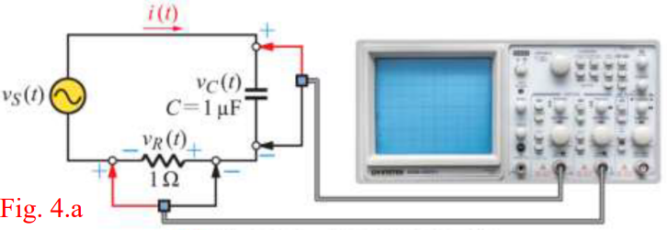

▲ Figure 1. Circuit of Experiment 4.a Pure Capacitive AC Circuit

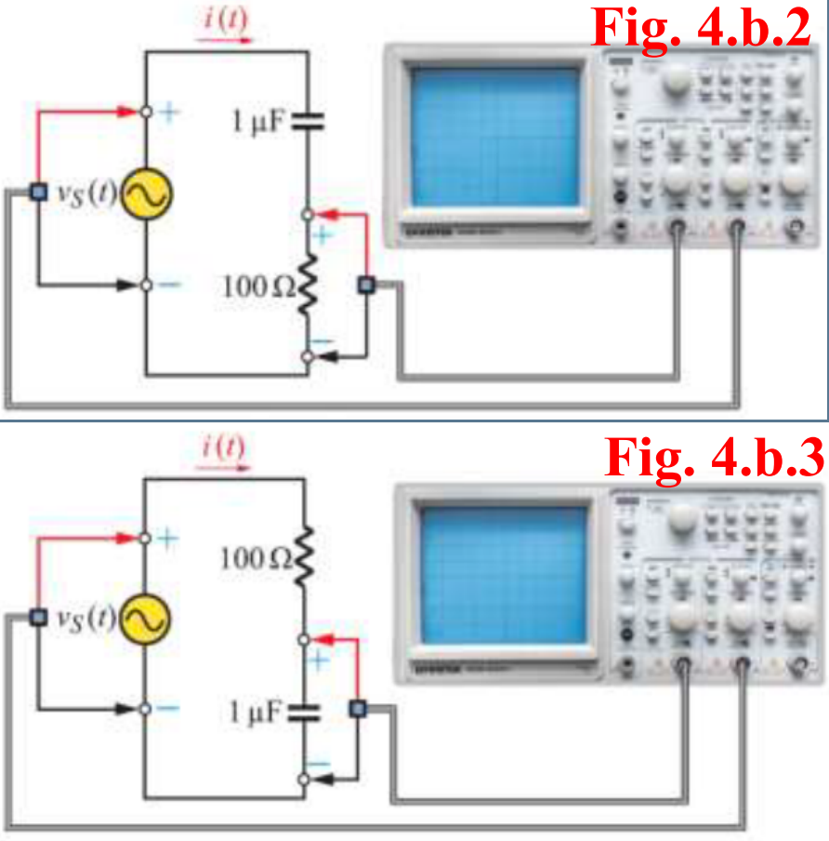

▲ Figure 2. Circuit of Experiment 4.b RC Series Circuit

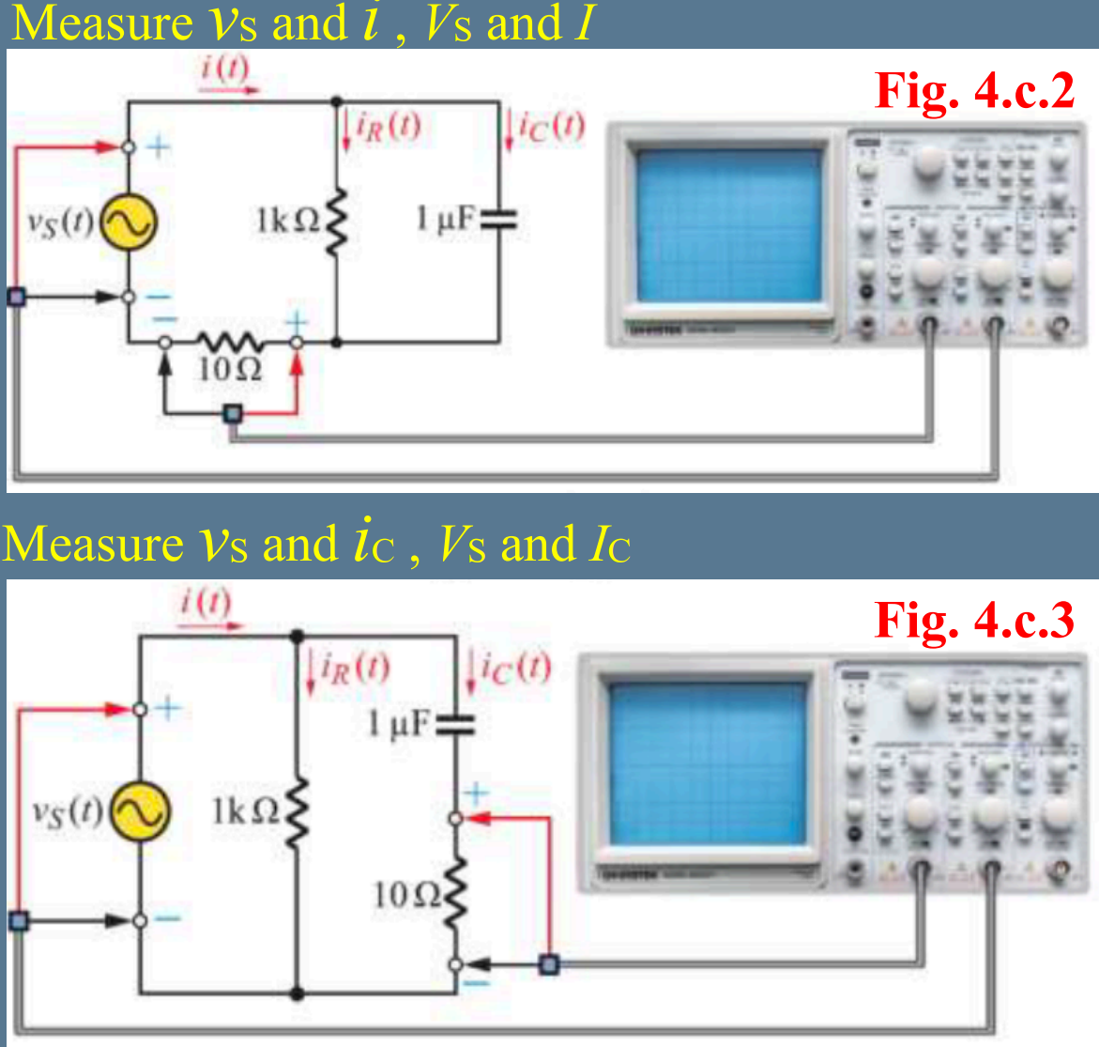

▲ Figure 3. Circuit of Experiment 4.c RC Parallel Circuit

1. Methods

Using Digital Multimeter to observe current and voltage and Oscilloscope to observe the wave.

1. Experiments data
   1. Experiment 4.a Pure Capacitive AC Circuit

Table 1: Measurement of Pure Capacitive AC Circuit

|  |  |  |  |  |
| --- | --- | --- | --- | --- |
| f | XC | I | | θ |
| Theoretical | Measurement |
| 100 Hz | 1591.5 Ω | 0.889 mA | 0.923 mA | 1.62° |
| 500 Hz | 318.3 Ω | 4.443 mA | 4.425 mA | -90.05° |
| 1 kHz | 159.2 Ω | 8.886 mA | 8.324 mA | -90.24° |
| 10 kHz | 15.9 Ω | 88.858 mA | 23.062 mA | -120.79° |

* 1. Experiment 4.b RC Series Circuit

Table 2: Measurement of RC Series Circuit

|  |  |  |  |  |
| --- | --- | --- | --- | --- |
|  | VS | VR | VC | I |
| Theoretical | 1.414 V | 0.7072 V | 1.224 V | 7.071 mA |
| Measurement | 1.2347 V | 0.5983 V | 1.0494 V | 6.024 mA |

|  |  |  |  |
| --- | --- | --- | --- |
|  | XC | Z | I leads VS by |
| Theoretical | 173.1087 Ω | 199.9802 Ω | 59.9806° |
| Measurement | 174.1999 Ω | 204.963479 Ω | 57.6° |

* 1. Experiment 4.c RC Parallel Circuit

Table 3: Measurement of RC Parallel Circuit

|  |  |  |  |  |
| --- | --- | --- | --- | --- |
|  | VS | XC | Z | I leads VS by |
| Theoretical | 3 V | 750.7508 Ω | 600.4804 Ω | 53.1033° |
| Measurement | 2.8563 V | 731.8217 Ω | 581.0212 Ω | 111.8° |

|  |  |  |  |
| --- | --- | --- | --- |
|  | I | IR | IC |
| Theoretical | 4.996 mA | 3 mA | 3.996 mA |
| Measurement | 4.916 mA | 2.893 mA | 3.903 mA |

1. Results

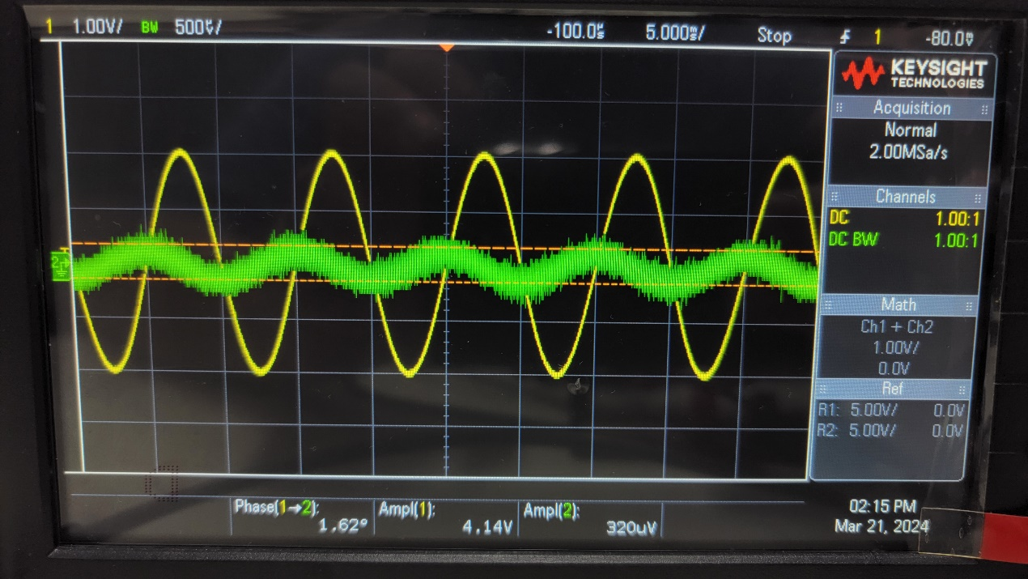

▲ Figure 4. Results of Experiment 4.a 100 Hz

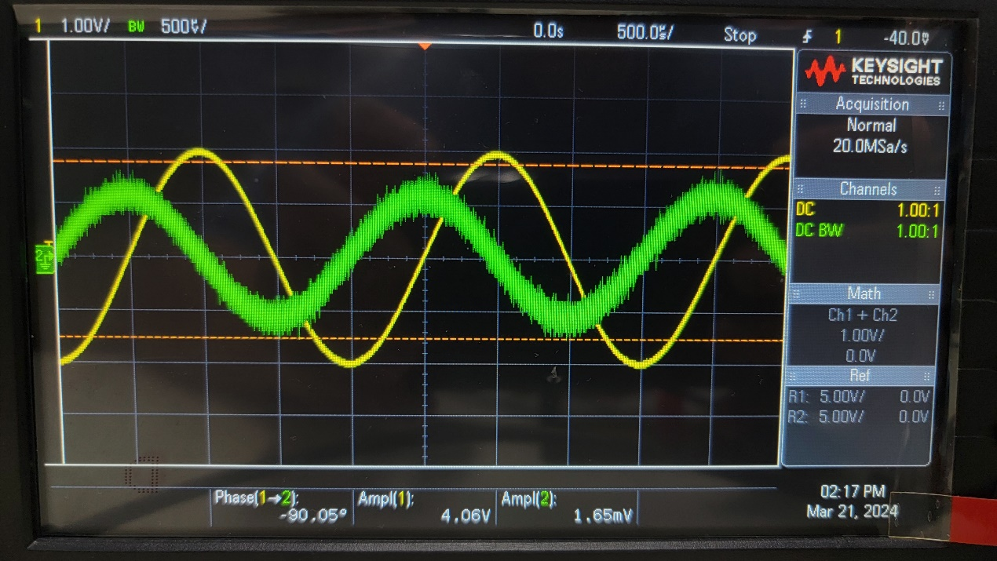

▲ Figure 5. Results of Experiment 4.a 500 Hz

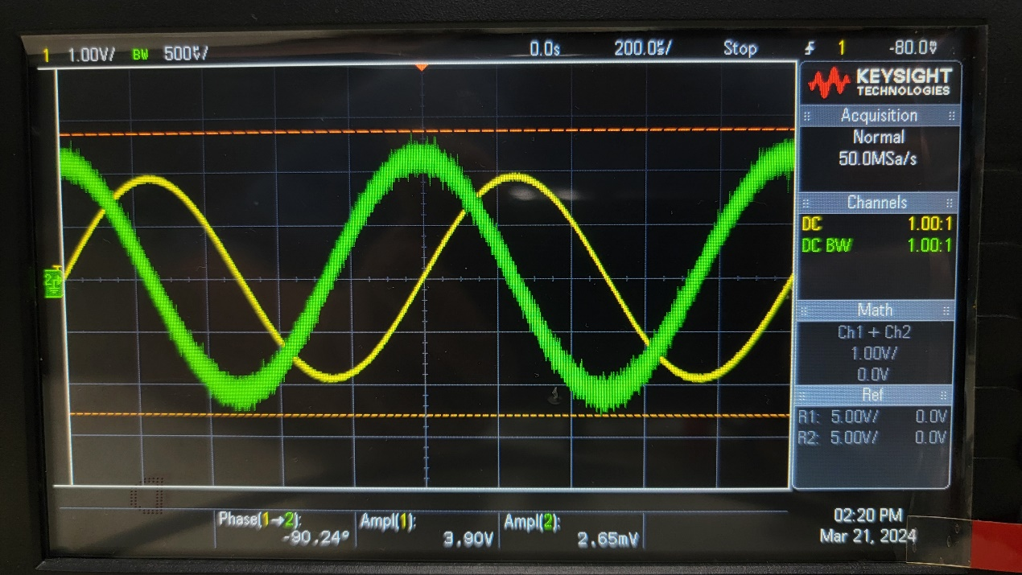

▲ Figure 6. Results of Experiment 4.a 1 kHz

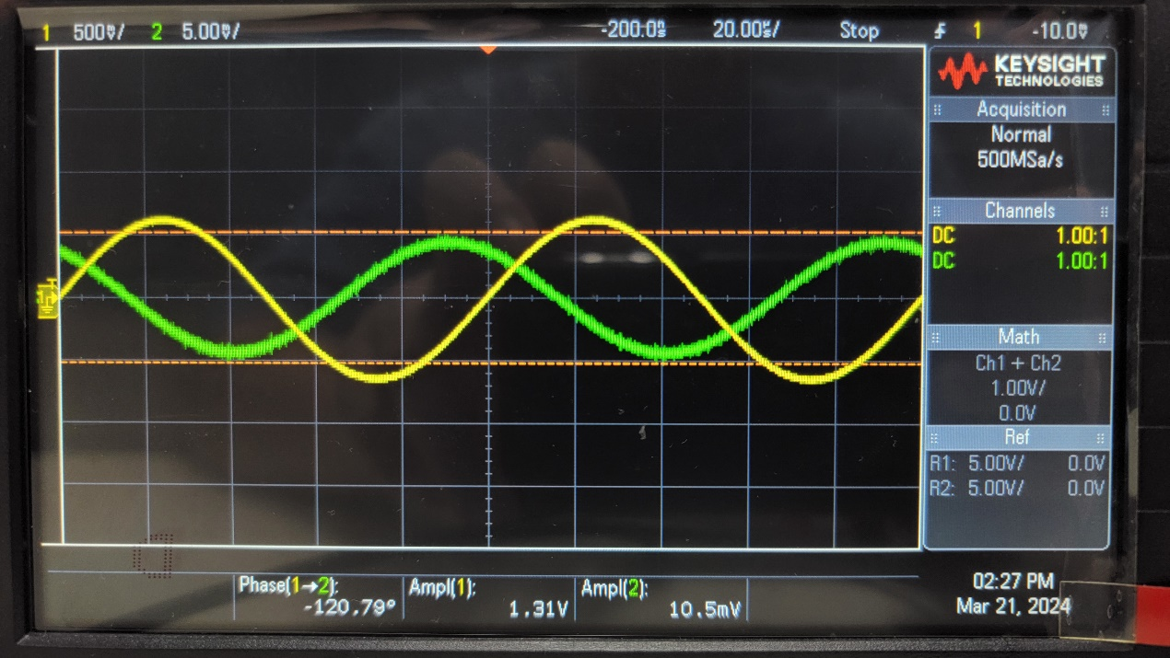

▲ Figure 7. Results of Experiment 4.a 10 kHz

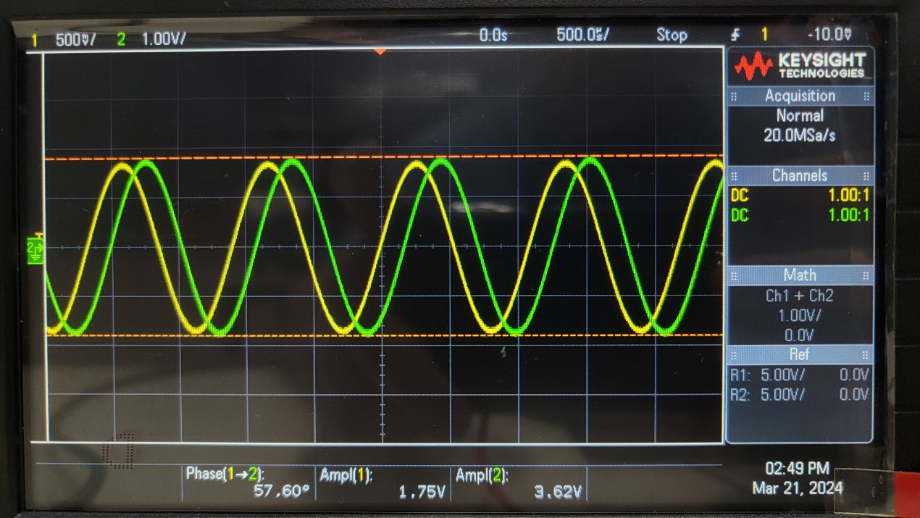

▲ Figure 8. Results of Experiment 4.b.2

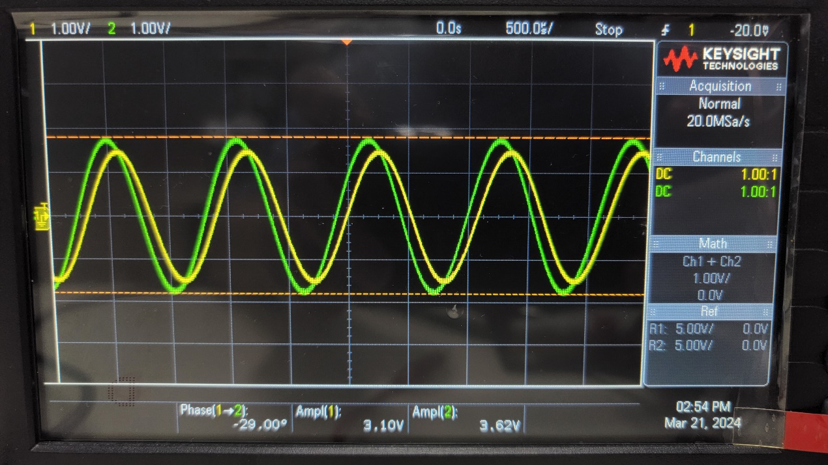

▲ Figure 9. Results of Experiment 4.b.3

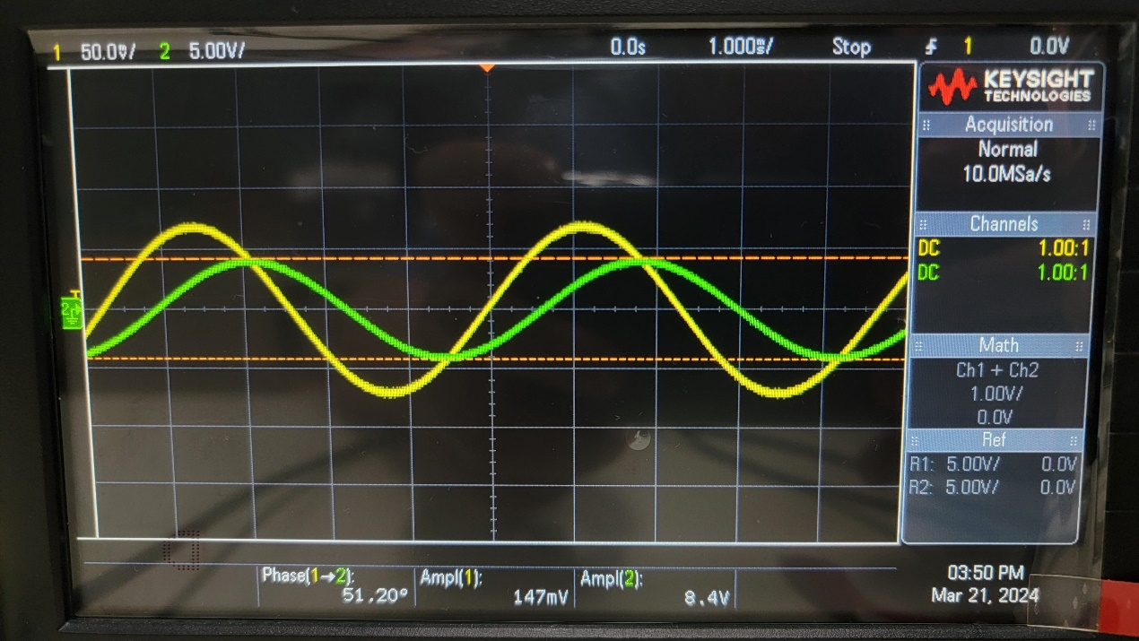

▲ Figure 10. Results of Experiment 4.c.2

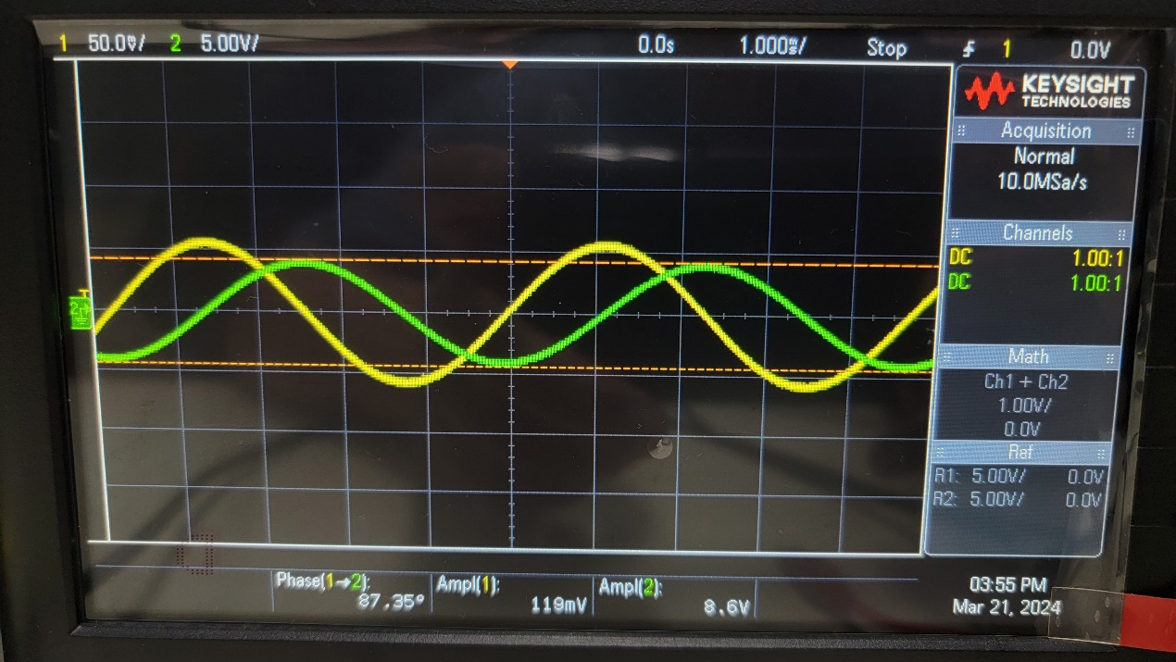

▲ Figure 11. Results of Experiment 4.c.3

1. Discussion

Explain why the phase lead between current and voltage for the capacitor is not 90°?

Because of the impedance and resistance involved, the phase lead will not be exact 90°. But the higher the frequency is, the phase lead will be more close to 90°.

1. Conclusion

From the graphs above, current will lead voltage.